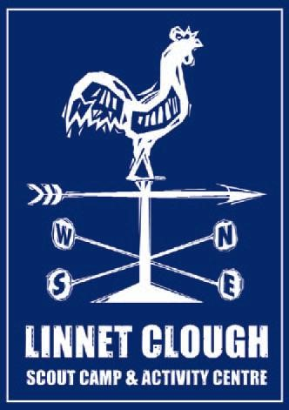

**Cubtober Booking Form**

Please complete the Booking Form with your final numbers and return via email to [events@linnetclough.org.uk](mailto:events@linnetclough.org.uk). Your booking will be confirmed back to you.

Payment in full is required at time of booking.

Please use **‘*Cubtober/Group name’*** as payment reference.

Bookings will close 28th September 2025

We reserve the right to close bookings once all places have been booked.

BACS payment details: Account Name: G.M.E.C.S.C. Linnet Clough

Sort Code: 16-00-01 Account Number: 12565965

|  |  |
| --- | --- |
| **Leaders Name:** | **Group Name:** |
| **Email:** | **Telephone:** |
| **Comments** |  |

|  |  |
| --- | --- |
| **Cubs £35 Camping**  **£30 Day Visitors Saturday** | **18+ Leaders £5** |
| X @ £35 = X @ £30 = | X @ £5 = |
| Total amount paid via BACS **£** | Date Payment made |

The event price covers site fees and activities.